

DS-K4H258S
One-Door Magnetic Lock
The DS-K4H280S one-door magnetic lock is designed for wooden door, glass door, and steel door with the opening angle of 90°. The maximum thrust of the lock is 280kg. It can be used for controlling door opening/closing, and the indicator shows the door status. | 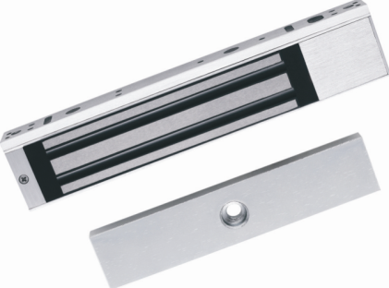

AVAILABLE MODEL

DS-K4H258S

MAIN FEATURES

- The magnetic lock supports static linear thrust of 280kg(550Lbs);
- Default voltage is 12VDC;
- It is equipped with internal voltage dependent resistor (MOV);
- It is applied to wooden door, glass door, metal door and fireproof door;
- LED indicator displays the status of door lock;
- Anti-residual magnetism design
- Abrasion-proof materials;
- The shell is made up of aldural and is hard anodizing electroplated;
- No mechanical failure, and the magnetic lock works by electromagnetism force;
SPECIFICATIONS

Model | DS-K4H258S
Dimension of Lock Body (L×W×H) | 238×45×25mm (9.4×1.8×1.0")
Dimension of Armature Plate (L×W×H) | 182×38×12.5mm (7.2×1.5×0.5")
Unlock Method | Current Interruption
Maximum Thrust | 280kg(550Lbs) Linear Thrust
Input Voltage | 12 VDC
Working Current | 340mAx2
LED Indicator | Green (Work Status)
Suitable Door | Wooden Door, Glass Door, Metal Door, Fireproof Door
Surface Temperature | ≤ Ambient Temperature +20°C (68°F)
Working Temperature | -10°C~+55°C (14°F~131°F)
Working Humidity | 0~95% (Relative Humidity)
Shell | Hard Anodizing Electroplating Operated
Lock Body | Eco-friendly Nickel Electroplating Operated
Armature Plate | Eco-friendly Zinc Electroplating Operated
Weight | 2.1kg

